Insertando imagen...

ACME-SF

G1.007

**Configuration Report**

14 February, 2024



# Cover

|  |  |
| --- | --- |
| **Repository:** <https://github.com/DP2-C1-07/Acme-SF-D01> | |
| **Student #1**  **ID:** 31878881F  **UVUS:**  pabcabmar3  **Name:** Caballero María, Pablo **Roles:** manager, developer | **Student #2**  **ID Number:**49034820Q  **UVUS:** mararnmon  **Name:** Arnáiz Montero, Marco Antonio  **Roles:** developer, operator |
| **Student #3**  **ID Number:** 77865211E  **UVUS:**  alfalolan  **Name:** Alonso Lanzarán, Alfonso Luis  **Roles:** developer, tester | **Student #4**  **ID Number:** 53932912M  **UVUS:** albsanmim  **Name:** Sánchez Mimbrero, Alberto  **Roles:** developer |
| **Student #5**  **ID Number:** 48123111G  **UVUS:** juagarcar4  **Name:** Garcia Carballo, Juan  **Roles:** developer |  |

Table of contents

Cover 2

Executive summary 2

Revision table 2

Introduction 2

Contents 3

Conclusions 10

Bibliography 10

# Executive summary

# Revision table

|  |  |  |
| --- | --- | --- |
| Number | Date(dd/mm/yyyy) | Description |
| 1.0 | 14/02/2024 | Document done in its entirety, reviewed by peers. No major errors were found. |

# Introduction

In this report, we will detail the setup of our development configuration as per the guidelines provided. Our focus is not to replicate the instructions for configuring the development environment but rather to demonstrate that we have adhered to them and have successfully prepared our development configuration for operation.

This document has an executive summary, a revision table where there are versioned records, this introduction, the main content, and the conclusions of the report.

# Contents

**Student #1 - Caballero María, Pablo**

Import the starter project:

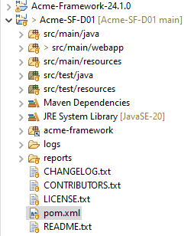

Modify pom and application properties files:

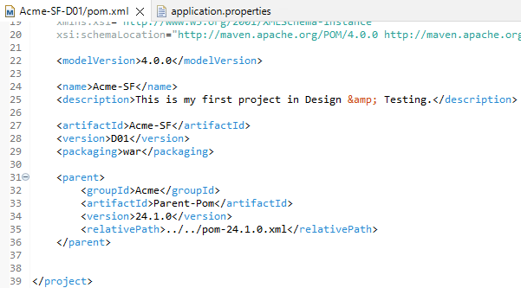

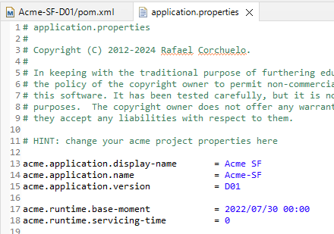

Run database scripts:

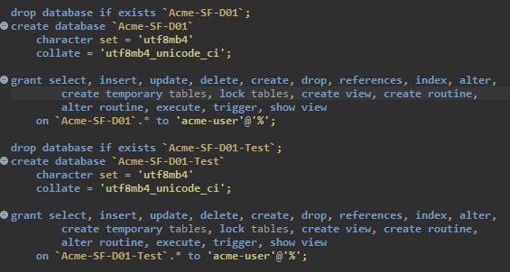

The database is populated:

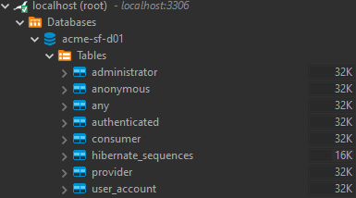

Run MariaDB:

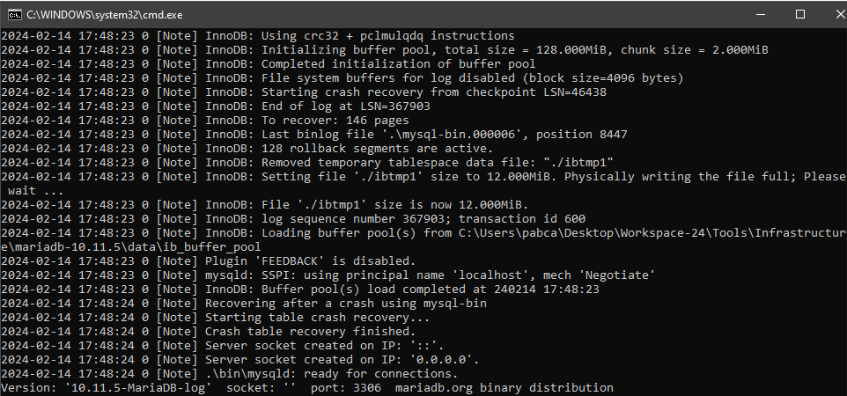

Create launchers:

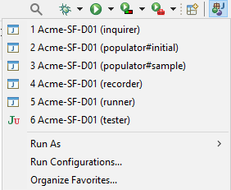

Run app:

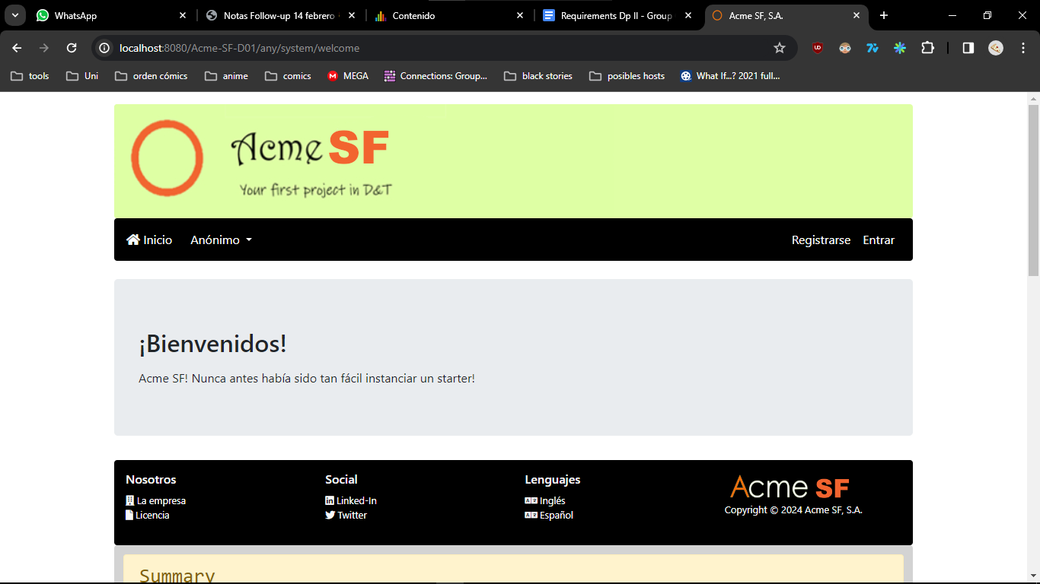

**Student #2 - Arnáiz Montero, Marco Antonio**

Run DB script:

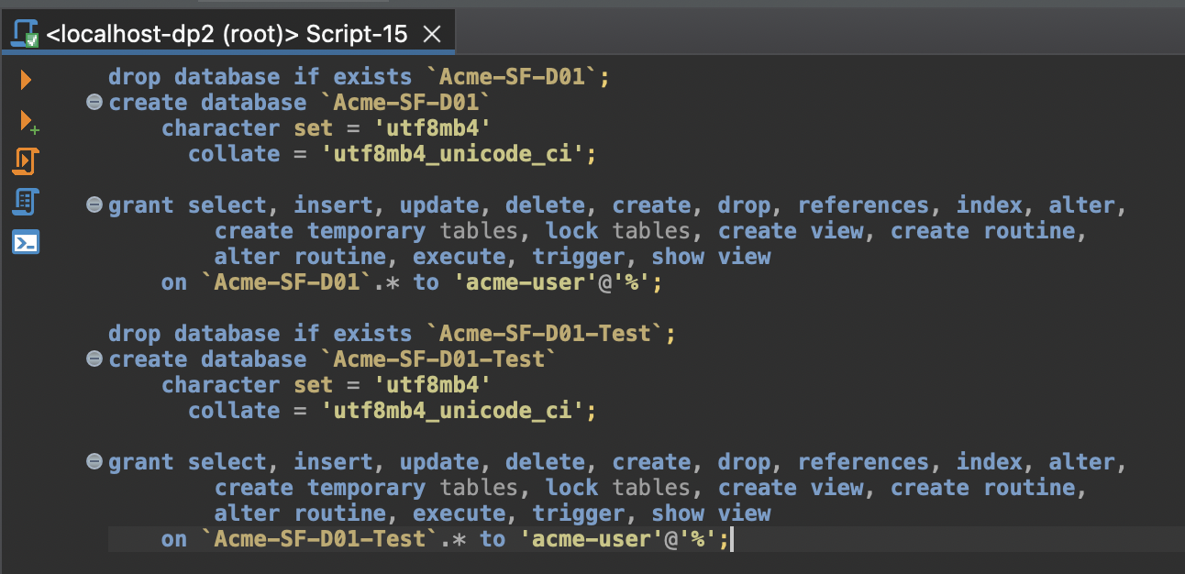

Eclipse configurations

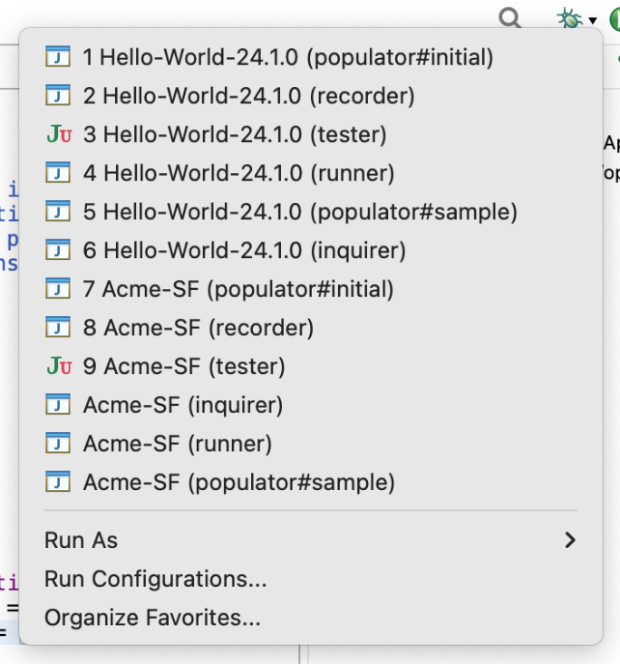

Run Acme-SF (runner) script

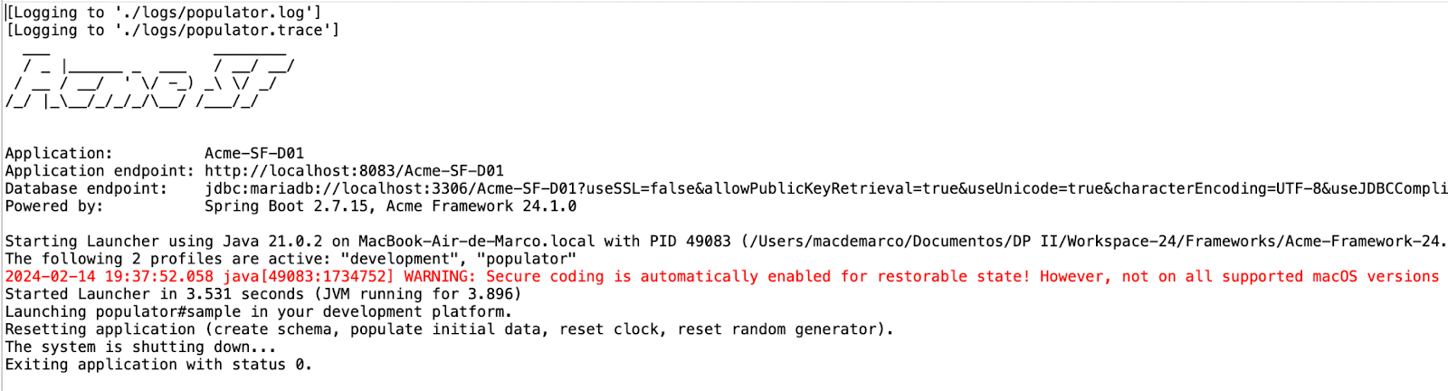

App:

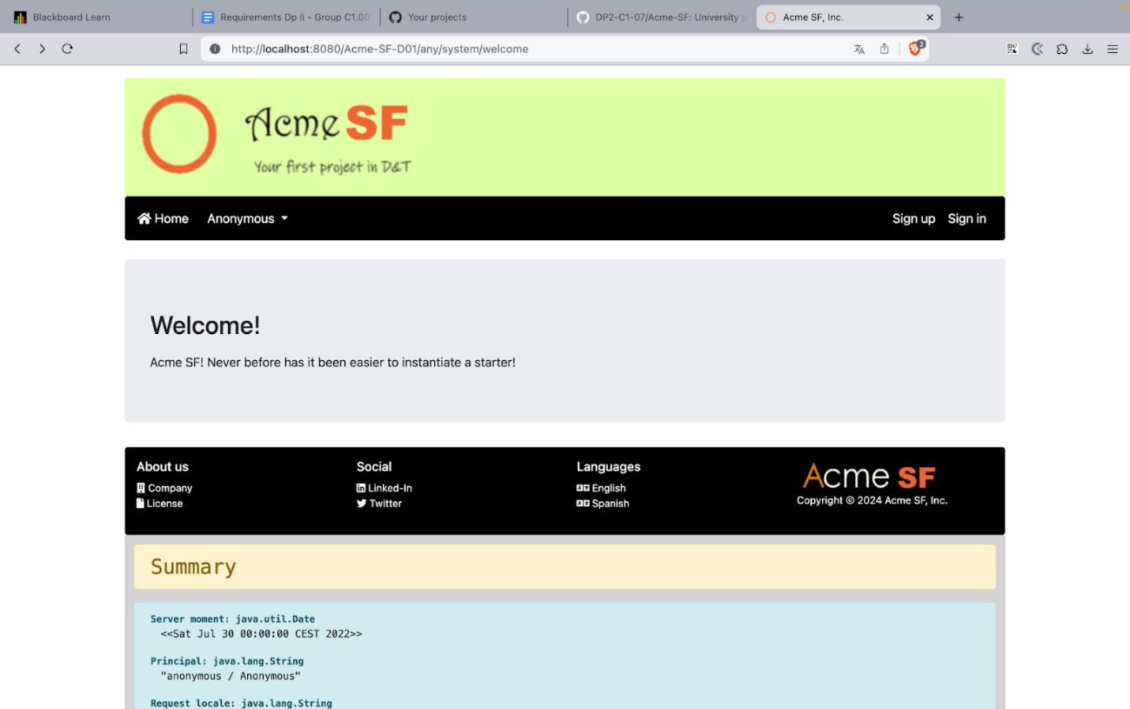

**Student #3 - Alonso Lanzarán, Alfonso Luis**

DB running:

Launchers created:

Database populated:

Application running:

**Student #4 - Sánchez Mimbrero, Alberto**

DB creation script:

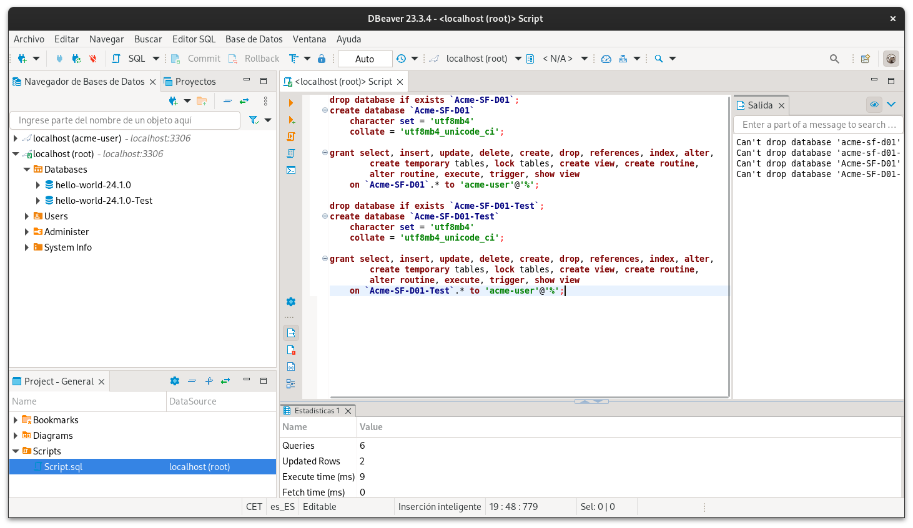

Eclipse configurations:

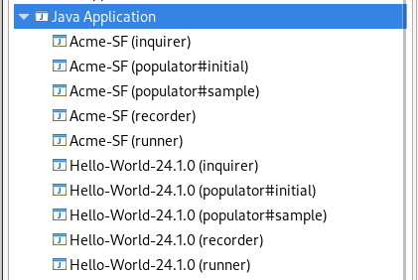

Acme-SF (runner) logs:

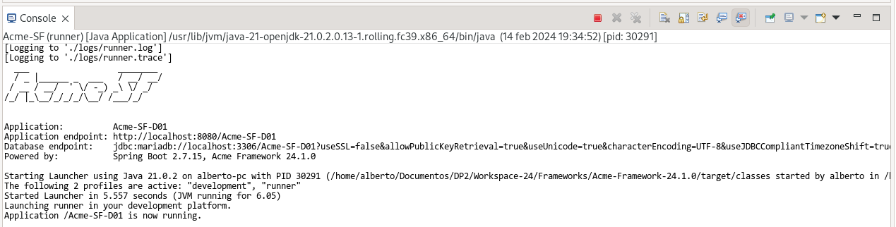

Running application:

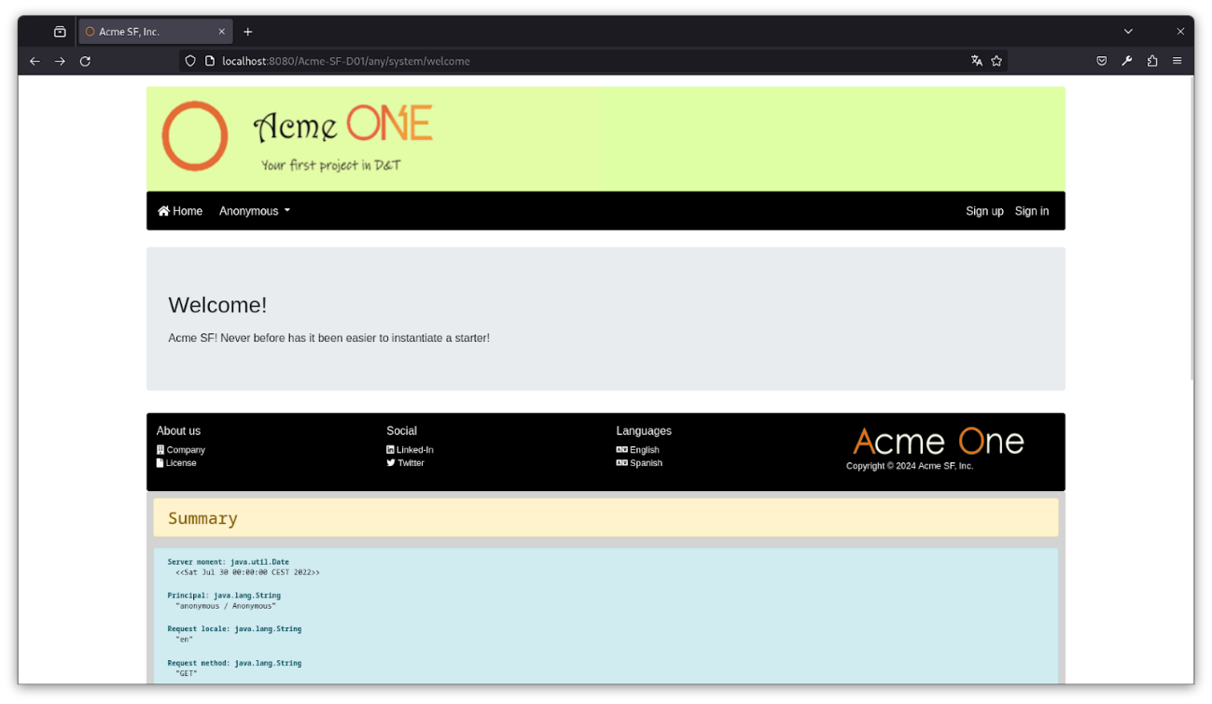

**Student #5 - Garcia Carballo, Juan**

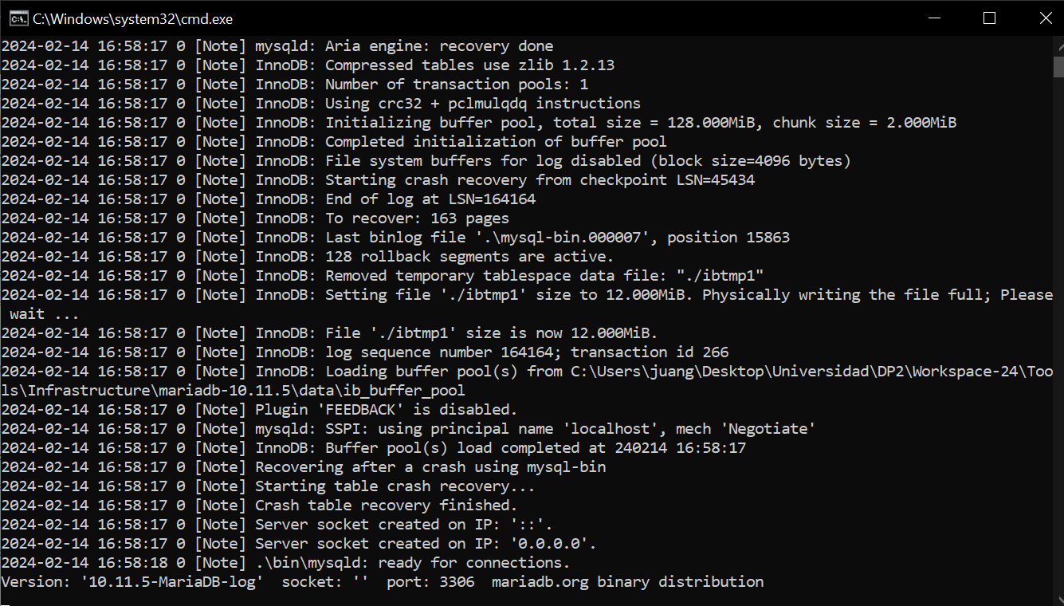

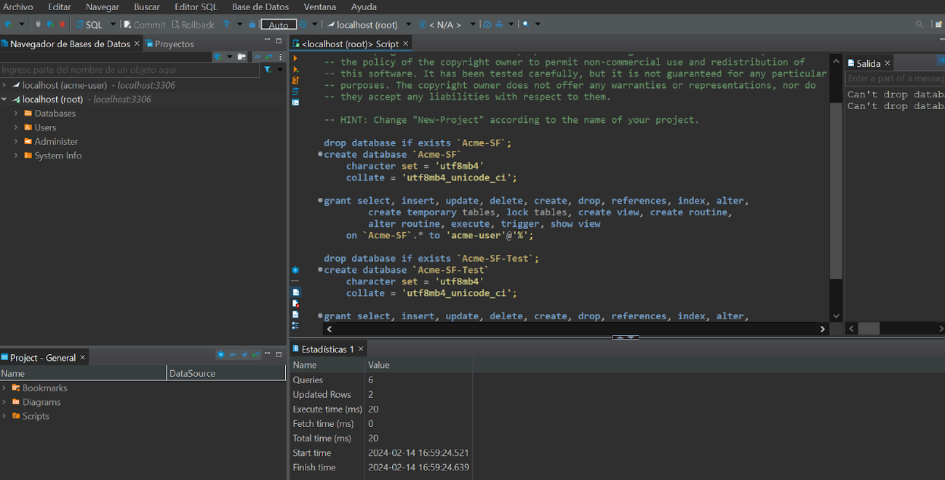

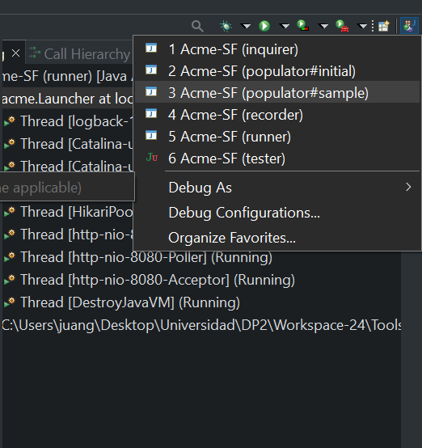

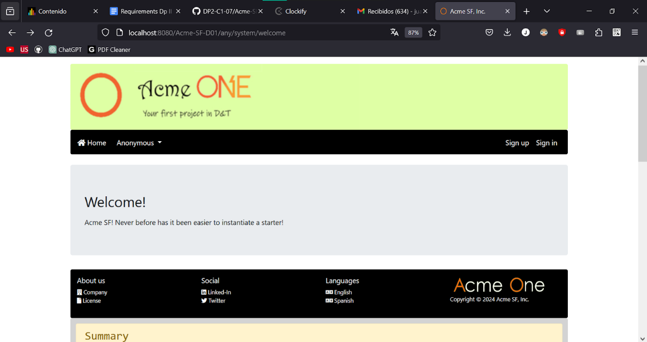

# Conclusions

Intentionally blank

# Bibliography

Intentionally blank